**ITEM MAINTENANCE AND CATEGORY**

* **TO START, GO TO  
  1.) Menu  
  2.) MAINTENANCE  
  3.) ITEM MAINTENANCE**

Maintenance

2 1*1*

Item Maintenance

33 1*1*

Menu

1 1*1*

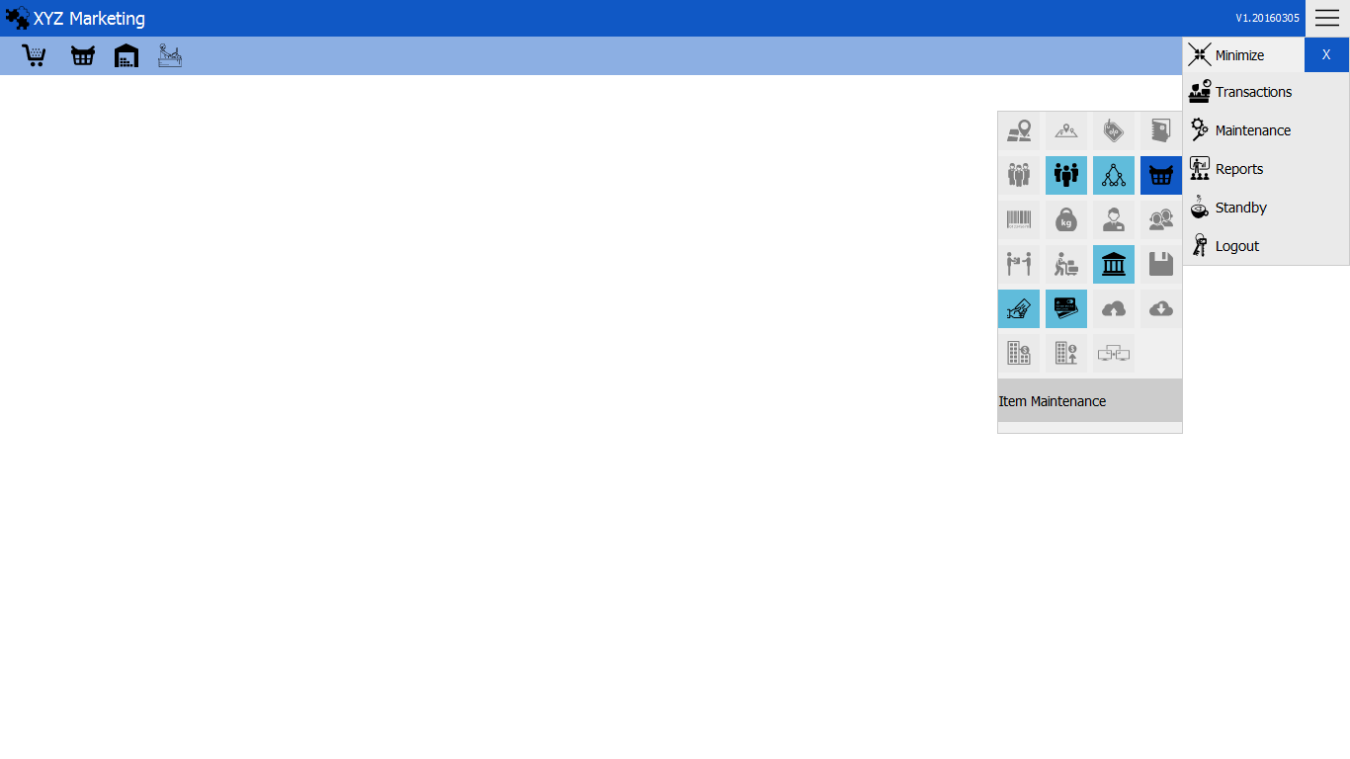

**NEW ITEM**

**1.) Input item description   
2.) Input item cost  
3.) Input item selling price  
4.) Select item category  
5.) Select item sub-classification  
6.) Select item model  
7.) Input reorder Level  
8.) Select item status  
9.) Select selling type  
10.) Input unit  
11.) Item classification  
12.) Item details  
13.) Add**

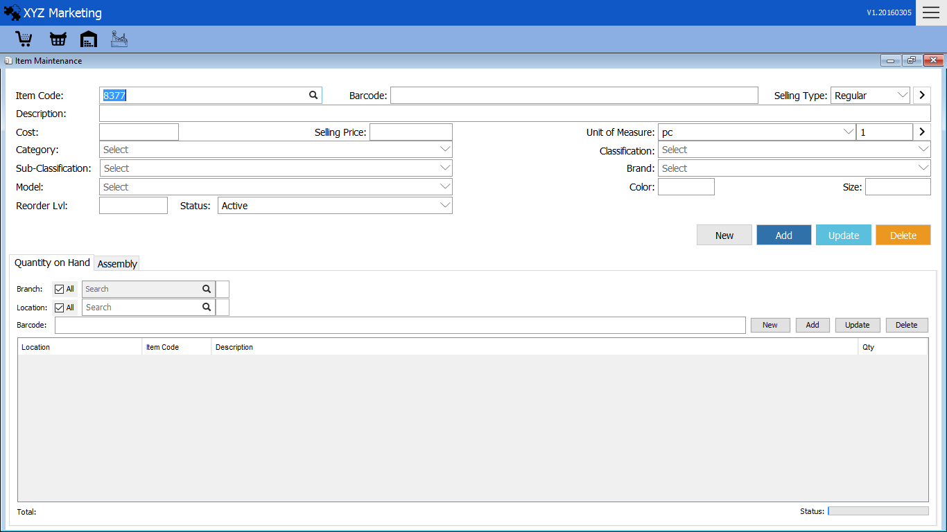

Add

Item Details

Item Classification

Unit

Selling Type

Item Status

9

Reorder Level

Item Model

Sub Classification

Item Category

12

11

10

8 1*1*

7 1*1*

6 1*1*

5 1*1*

4 1*1*

3 1*1*

1 1*1*

Description

Item Cost/ Selling Price

2 1*1*

Item Code - automatically generated  
Barcode – Barcode scanner  
Unit of Measure – Default (pc)

**1.) Description**



Input item description which you can see in the item.

**2.) Input item cost**



Input item cost (Supplier’s Price)  
Input Selling Price (Price of the item for sale)

**3.) Select item category**

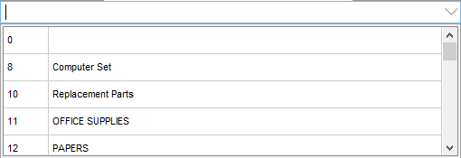

Choose the item category displayed upon opening the input box.

**4.) Sub-classification**

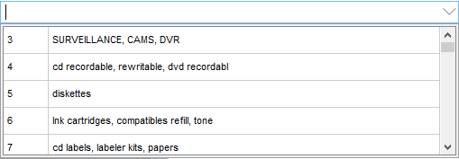

Choose the item sub-classification displayed upon opening the input box.

**5.) Item model**

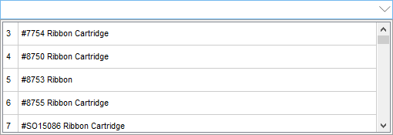

Choose the item model displayed upon opening the input box.

**6.) Reorder Level**



Input reorder level – minimum amount of item hold in the stock. When stock falls in to this level, the item must be reordered.

**7.) Select item status**

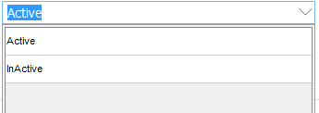

Select item status displayed upon opening the input box.

**8.) Selling Type**

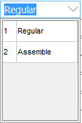

Select item selling type  
a.) Regular – Single item  
b.) Assemble - Separated component parts

**9.) Unit**

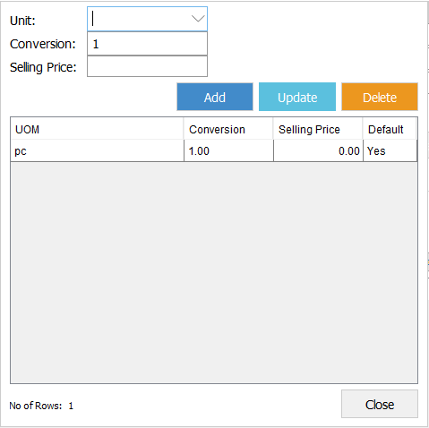

Add & Update

Selling price

Conversion

Unit

4 1*1*

3 1*1*

2 1*1*

1 1*1*

Button

Unit of measure – default (pc)  
We can also convert the default UOM by clicking the button in the right side.

**9.1) Input unit to be converted**

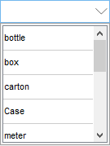

Select the unit that pc is to be converted

**9.2) Conversion**



Input number that is equivalent to (1) pc in the converted unit

**9.3) Selling Price**



Multiply the equivalent conversion to the original selling price.

**9.3) Add & Update**



After filling the details click add button to finish.  
or update to add or change in the existing items.

**10.) Item classification**

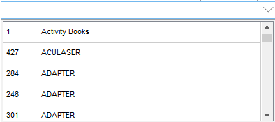

Choose Item classifications displayed upon clicking the input box.

**11.) Item detail**

Choose item brand displayed upon clicking the input box.  
Color – Input the color of the item.  
Size – Input the size of the item.

**11.) Add**

After filling all the details of the item click the add button to finish.

**11.1) Update**

You can update by searching the item code.



Update the details and click the update button to finish



**Categories**

Categories

3 1*1*

Maintenance

Menu

2 1*1*

1 1*1*

You can also add or edit categories.

